__________________________________________________________________________________________
SETA: Consider the given undirected weighted graph on the left where the vertices are labeled using numerical values:
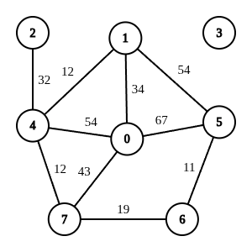
IX) Draw the Matrix representation of this graph.
X) Show the traversal sequence of performing a Depth-First Search (DFS) traversal starting from the vertex 6.
When a vertex has more than one neighbor, you can choose the next neighbor based on the descending order of the numerical label on the vertices.
XI) Which edges were NOT traversed during your simulation? Write down their sources, destinations & weights.
For example: <5 - 0 : 67> means an edge from 5 to 0 with 67 weight.
